Routing To The Html Page

|  |  |
| --- | --- |
| Date | 13 November 2022 |
| Team ID | PNT2022TMID51066 |
| Project Name | AI-powered Nutrition Analyzer for Fitness Enthusiasts |

Here, the declared constructor is used to route to the HTML page created earlier.

In the above example, the ‘/’ URL is bound with the home.html function. Hence, when the home page of the webserver is opened in the browser, the HTML page is rendered. Whenever you enter the values from the HTML page the values can be retrieved using the POST Method.

Here, “home.html” is rendered when the home button is clicked on the UI

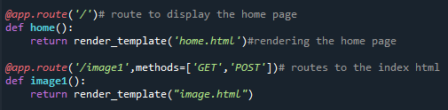

When “image is uploaded “on the UI, the launch function is executed



It will take the image request and we will be storing that image in our local system then we will convert the image into our required size and finally, we will be predicting the results with the help of our model which we trained and depending upon the class identified we will showcase the class name and its properties by rendering the respective html pages.

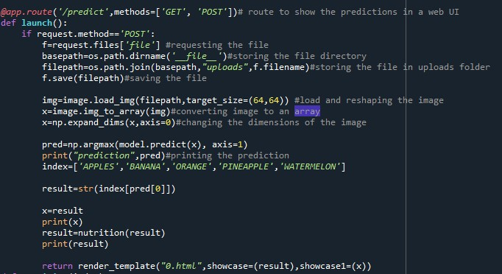

API Integration:

Here we will be using Rapid API

Using RapidAPI, developers can search and test the APIs, subscribe, and connect to the APIs — all with a single account, single API key and single SDK. Engineering teams also use RapidAPI to share internal APIs and microservice documentation.

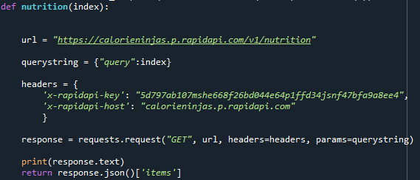

Finally, Run the application

This is used to run the application in a localhost. The local host runs on port number 5000.(We can give different port numbers)

